

**Affordable Home Ownership**

With support from the federal and provincial governments, affordable homeownership in Toronto has been supported for three reasons:

1. To help low and moderate income households build equity and escape the cycle of poverty;
2. To make more social housing and private rental housing units available by helping renters become homeowners;
3. To develop more socio-economically mixed neighbourhoods.

**Types of Homes**

Affordable home ownership is available through one of the City of Toronto’s partners. Condo units and/or homes of various sizes are available.

**Who Is Eligible?**

To be eligible for affordable home ownership through the City of Toronto’s program,

you must:

* Be at least 18 years old and be a legal, permanent resident of Canada;
* Not own a home or have an ownership interest in a home;
* Cannot be living in a spousal relationship with a person who owns a home or has

an ownership interest in a home;

* Purchase an eligible unit;
* Currently be renting;
* Not have a **total** annual household income that is more than $88,900. This must

include the income of anyone living in the home with whom the homeowner is in

a spousal relationship, or is over 18 and will be living in the home.

As well, eligible candidates must:

* Agree to live in the unit as his or her principal residence while they own the unit;
* Obtain his or her own primary financing for the purchase of the Eligible unit
* Complete an application for a loan that includes:
  + Photo ID
  + Original assessment notice from the Canada Revenue Agency or other

Equally reliable evidence of stable income

* Signing a declaration all information in the application is true.

**Where Can I Find Out More?**

You can find out more about Toronto’s Affordable Home Ownership Program

and how to apply by contacting one of the Partners. You can find out more by visiting

<https://www1.toronto.ca/wps/portal/contentonly?vgnextoid=9ab857b8920b0510VgnVCM10000071d60f89RCRD&vgnextchannel=310fab2cedfb0410VgnVCM10000071d60f89RCRD>

Since 1992, the City of Toronto has helped more than 1,100 households achieve their goal of home ownership.

**Toronto’s Affordable Home Ownership Partners Include:**

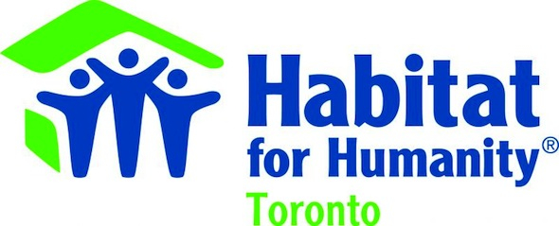

*& Women’s Religious Project*



http://www.yongestreetmedia.ca/galleries/companyLogos/Issue_38/hoanc.jpg



